PROJECT REPORT: SWIFT ROUTE LOGISTICS PERFORMANCE DASHBOARD
Name: Neelay Upadhyay
Roll No: 2306296
Branch: Information Technology
Course: Power BI

1. PROJECT TITLE
Swift Route Logistics: End-to-End Operational Intelligence & Fleet Management System

2. PROBLEM STATEMENT
In the contemporary logistics landscape, data fragmentation often leads to operational bottlenecks. Swift Route Logistics face a critical lack of real-time visibility into their supply chain. The primary challenges addressed in this project include:
- Operational Delays: Difficulty in pinpointing whether delays were caused by hub processing, vehicle breakdowns, or driver inefficiency.
- Resource Imbalance: Inconsistent workload distribution across different hubs, with some operating at 120% capacity while others remained underutilized.
- Fleet Maintenance: High breakdown rates in older vehicles without a proactive replacement or maintenance schedule.
- Customer Satisfaction: Lack of correlation between delivery times and customer satisfaction scores (CSAT).

3. SOLUTION & CORE FEATURES
The solution is a multi-dimensional Power BI suite that transforms raw transactional data into actionable insights through four specialized reporting layers:

A. Logistics Overview Dashboard
- Real-time KPI Tracking: Instant visibility into Total Orders, On-Time Delivery (OTD) rates, and CSAT.
- Time-Intelligence Integration: Comparative analysis of current month performance against previous month data to identify trends.
- Segmented Performance: High-level summary of Hub, Driver, and Vehicle performance on a single pane.

B. Dynamic Driver Profiling
- Individual Performance Cards: A fully dynamic profile page that updates based on the selected driver, showing their tenure, total deliveries, and experience.
- Custom Rating Visualization: Implementation of a visual star-rating system based on performance scores.

C. Hub Operations Deep-Dive

Capacity Planning: A visual comparison of "Order Processed vs. Hub Capacity" to assist in logistical rerouting.

Processing Efficiency: A matrix heatmap analyzing hub processing times by day of the week, identifying peak congestion periods.

D. Fleet & Maintenance Analytics
- Reliability Correlation: Scatter plots correlating vehicle age with breakdown frequency.
- Active Fleet Status: Real-time tracking of vehicles "Under Maintenance" vs. "Active" to prevent shipping delays.

4. TECH STACK & ARCHITECTURE
- Business Intelligence Tool: Power BI Desktop (Edition 2026).
- Data Transformation: Power Query (M-Language) for schema normalization and data type alignment.
- Data Modeling: Implementation of a Star Schema.
  - Fact Table: Orders (Transactional data).
  - Dimension Tables: Drivers, Hubs, Vehicles, and a custom Date Table.
- Advanced Analytics: DAX (Data Analysis Expressions) for complex measures including:
  - CALCULATE & DATEADD for MoM growth.
  - UNICHAR for graphical star ratings.
  - SELECTEDVALUE for dynamic reporting headers.

5. DATASET DESCRIPTION
The project utilizes 28,000+ rows of logistics data across four primary tables:
- Orders Table: Contains Order IDs, Actual vs. Estimated Delivery Dates, Hub IDs, and CSAT scores.
- Drivers Table: Stores driver metadata, including hiring dates and experience levels.
- Hubs Table: Contains geographical hub names and their daily processing capacities.
- Vehicles Table: Includes vehicle models, purchase dates, and maintenance alerts.

6. UNIQUE PROJECT POINTS
- Conversation-Style Logic: The dashboard doesn't just show numbers; it uses DAX-driven strings to explain performance (e.g., "Driver X achieved a 5-star rating this month").
- End-to-End Navigation: Custom page navigators allow users to move from "Logistics Dashboard" to "Individual Overviews" with a single click.

7. FUTURE IMPROVEMENTS
- Machine Learning Integration: Using the R/Python script integration in Power BI to forecast future delays based on historical weather patterns.
- Live API Connection: Replacing static CSVs with live SQL or Web API connections for real-time fleet movement.
- Cost-Benefit Analysis: Integrating fuel cost data to calculate the "Cost per Delivery Mile" for every vehicle model.

8. SCREENSHOTS & VISUALIZATIONS
The Logistics Overview Dashboard:
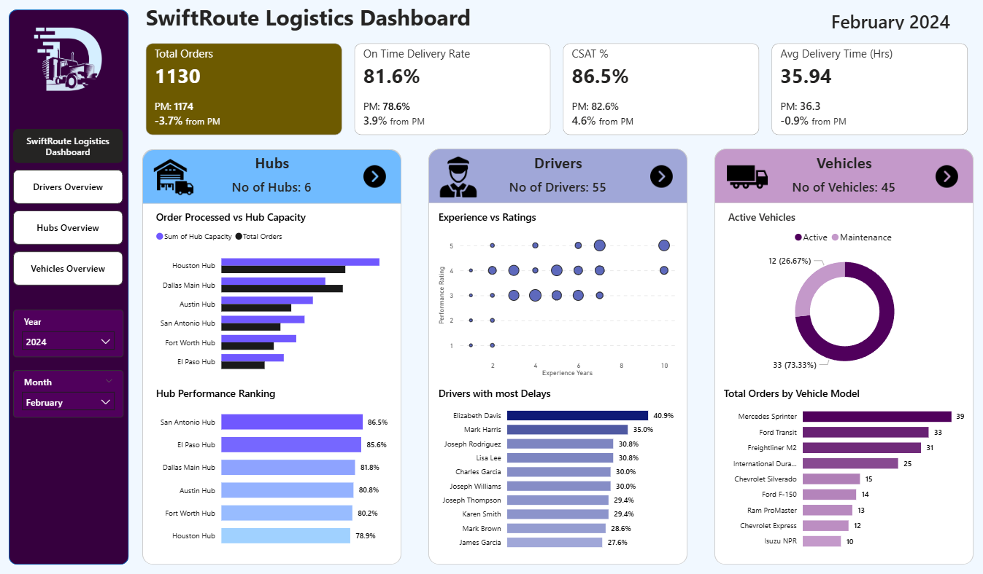
The Drivers Overview:
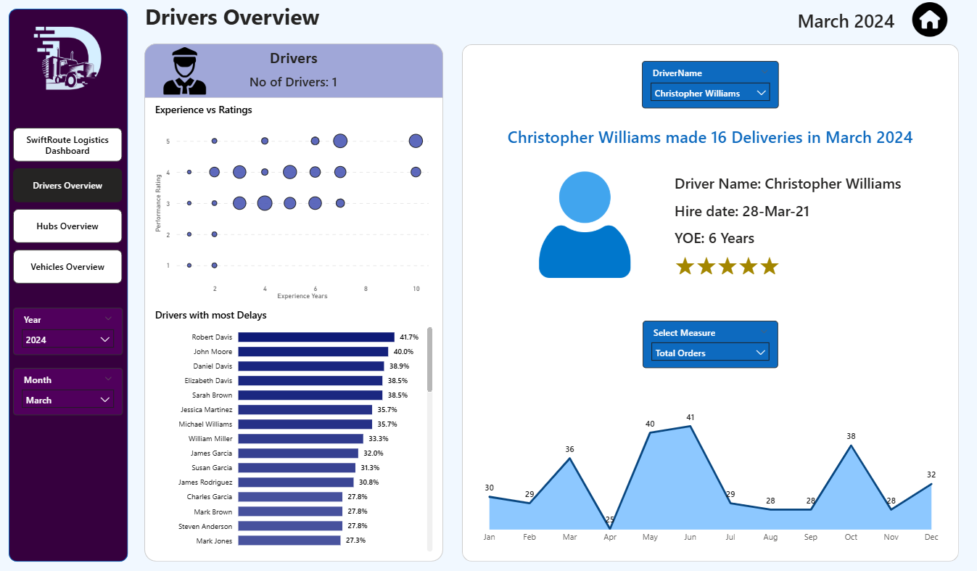
The Hubs Overview:
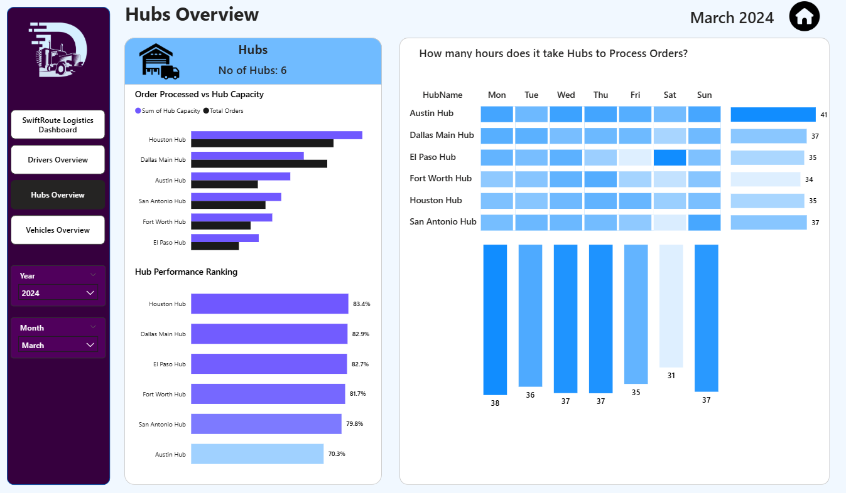
The Vehicles Overview:
